Final Report   
On  
LOGISTIC CHATBOT

Submitted To – Sir Sagar Pande

Submitted By – Shubham Soni (11804171)

**ACKNOWLEDGEMENT** –

In performing our assignment, I had to take the help and guideline of some respected persons, who deserve our greatest gratitude. The completion of this assignment gives us much Pleasure. I would like to show our gratitude SIR SAGAR PANDE for giving us a good guideline for assignment throughout numerous consultations. We would also like to expand our deepest gratitude to all those who have directly and indirectly guided us in writing this assignment. In addition, a thank you to Professor SAGAR PANDE, who introduced us to the Methodology of work. Many people, especially our classmates and team members itself, have made valuable comment suggestions on this proposal which gave us an inspiration to improve our assignment. We thank all the people for their help directly and indirectly to complete our assignment.

**ABSTRACT –**

It was a self-chosen project for AI course by me. Every website specially e-commerce websites are using chatbots for to simplify their task of giving replies to each and every individuals 24*7. They need to hire many employees for this purpose only. Although many chatbots are in working now-a-days but through this project I tried my best to reduce human efforts in this field. Starting from about many new libraries to GUI, I learnt a lot while working on this project. I this process I have gone through many video lectures, documents, presentation, research paper, etc.

**RELATED WORK –**

As I already mentioned above there are many working chatbots for many e-commerce websites which reduces human efforts.  
I have gone through and learned through many GitHub projects also and many of them have done a great job putting tremendous efforts.  
Many free lancers and many websites also build chatbot according to one’s requirement. I tested one of those chatbots and found many interesting ideas about my project.

**IMPLEMENTATION –**

There is difference between smart reply and reply. I stuck there only. Due to the lack of knowledge about how to use heuristics technique to produce a smart reply, my project gives you all the possible replies for a given question or text.  
For ex- if you type hello, it will provide you with all possible replies (hi, hello, hie, hy).

There are in total 4 python files- named –  
1. classes_dict.py  
2. ml_reply.py  
3. retrieval_based_Reply.py  
4. rule_based_reply.py.

classes_dict.py -> This file contains the data set used in this chatbot which is stored in this file in form of dictionaries. User need not to run this file.  
rule_based_reply.py -> This file is the script use to train the chatbot over the dataset available in classes_dict.py. User need not to run this file.  
ml_reply.py file -> It contains the code like bag of words, tokenizer, etc. which are used to manipulate the dataset and train the system. User need not to run this file.  
retrieval_based_Reply.py -> This file contains the code for user interaction, smart replies and all front-end details. User need to run this file to see the execution and to interact with the chatbot for getting replies to the typed messages.

User only need to run retrieval_based_Reply.py file to activate the chatbot and start getting replies to question asked. At any time to go out from the chat user need to type "exit" and press enter.

*Schedule ->*

Prepared the idea and plan of implementation. Looked for the existing chatbots and searched many e-commerce sites for their requirements.  
Discussed the ideas and all with sir and applied the given suggestions and worked as per suggested.  
Comes imp part, learned about all libraries in details, learnt their uses and implementation in my project.  
Took sir’s help in understanding some of the libraries as they were very new to me.  
Then, I started with my coding part, faced difficulties, watched videos, gone through related works and finally after so many days and many days of work I was near to success.   
But as I stated earlier, I was unable to apply heuristic search to provide smart reply that’s why I project gives all possible replies for a provided questions or texts.

**RESULT –**

*Initial interface ->*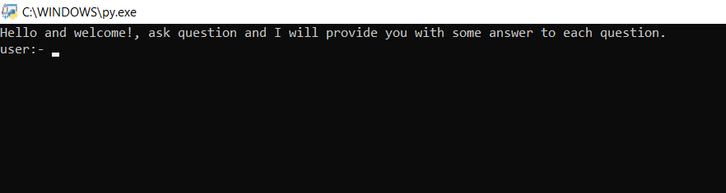

Bot giving all possible replies to hello ->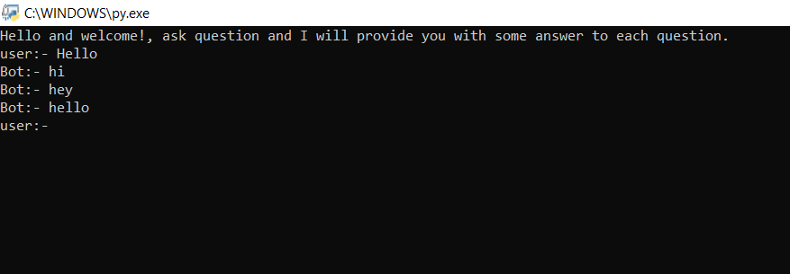

Bot replying to “How are you?” ->

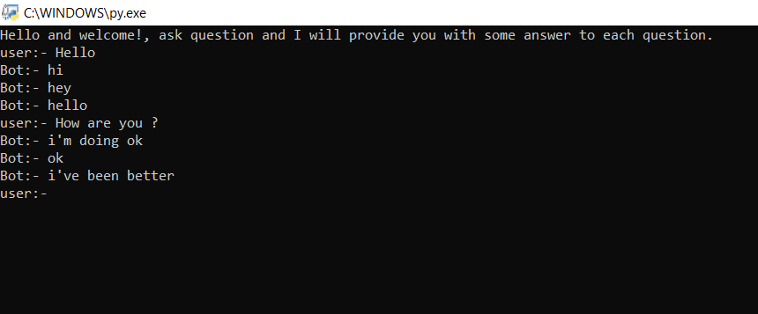

Logistic Chatbot (replying to related questions) ->

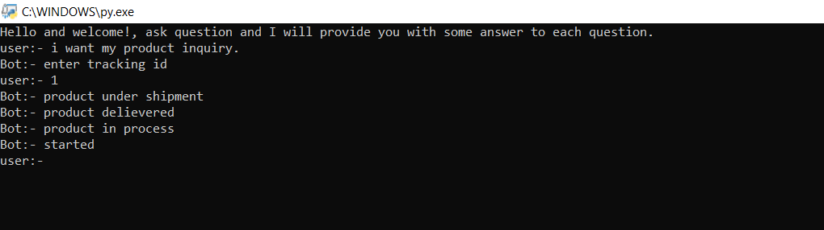

Finally, Thanks to the bot…. huh! ->

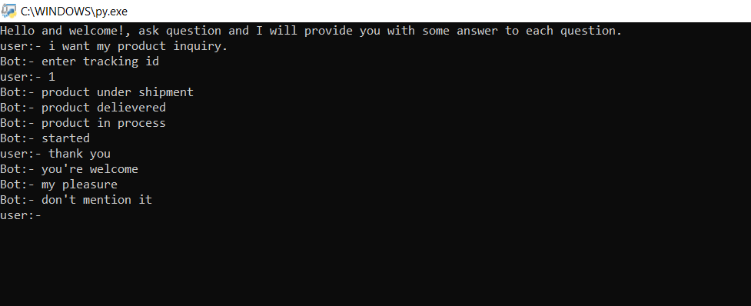

**LIBRARIES USED –**

nltk –

It contains text processing libraries for tokenization, parsing, classification, stemming, tagging and semantic reasoning.  
**Stemming** usually refers to a crude heuristic process that chops off the ends of words in the hope of achieving this goal correctly most of the time, and often includes the removal of derivational affixes. **Lemmatization** usually refers to doing things properly with the use of a vocabulary and morphological analysis of words, normally aiming to remove inflectional endings only and to return the base or dictionary form of a word, which is known as the lemma.

Re –

This module provides regular expression matching operations similar to those found in Perl. Both patterns and strings to be searched can be Unicode strings as well as 8-bit strings.

Pickle –

Pickling is a way to convert a python object (list, dictionary, etc.) into a character stream. The idea is that this character stream contains all the information necessary to reconstruct the object in another python script.

Random –

The random.choice() method returns a randomly selected element from the specified sequence. The sequence can be a string, a range, a list, a tuple or any other kind of sequence.

**TEAM RESPONSIBILITY –**

Alone member in the project.

**SCOPE –**

Scope of any chatbot depends on the data set used. As the dataset varies chatbot varies in different categories and as the dataset becomes larger, the project or chatbot becomes more useful and used for any purpose.

**REFERENCES –**

GOOGLE FIREBASE API

<https://becominghuman.ai/natural-language-processing-in-python-3-using-nltk-fd0ff4a0da9b>

<https://www.tensorflow.org/lite/models/smart_reply/overview>

<https://medium.com/datadriveninvestor/ai-chatbot-in-supply-chain-and-logistics-industry-fbca5c48040e>

<https://dzone.com/articles/python-chatbot-project-build-your-first-python-pro>